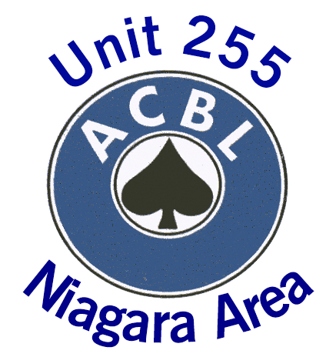
Unit 255 Board of Directors’ Meeting
April 20, 2022 7:00 PM
Via Zoom
Minutes

In attendance: Heather Beckman, Wiebe Hoogland, Kathy Morrison, Claude Tremblay, Muriel Tremblay,
Regrets: Steve Williams

- Welcome and Call to Order: Muriel called the meeting to order at 19:00
- Purpose of this special meeting is to discuss and approve the AGM event and budget
  - It was decided that we will hold a special event including a Unit Club Championship game and catered dinner on May 21 2022 at the NOTL Community Centre
  - The menu as presented was approved
  - The budget and ticket prices were approved with the agreement that we must pre-sell dinner tickets. If we do not achieve the target of 12 tables, then we will cancel the dinner and refund the money to those who have purchased tickets
  - Responsibilities were determined as follows:
    - Heather to prepare a message to be sent to all Unit 255 members
    - Muriel to make arrangements for the catered dinner and to ask Verne to be our bar tender
    - Claude to prepare and produce tickets for sale
    - Wiebe and Kathy to arrange for table cloths, dinner plates, cutlery, wine glasses from BCON
    - Each Board member will promote the AGM to players at the two clubs and tickets will be sold at each of the clubs
    - More responsibilities may arise as we develop a more detailed plan

Next Meeting: TBD

Meeting adjourned 19:30

